Library Management System :

Library Data:

1- Book

Attributes:

* Book id
* Tittle
* Author
* Publisher
* Year published

2-Member

Attributes:

* Member id
* Name
* Phone
* Email

3-Borrowing

Attributes:

* Borrow id
* Borrow date
* Return date

ERD:

Mapping:

Normalization:

**Question 5:**

**create tables and insert data:**

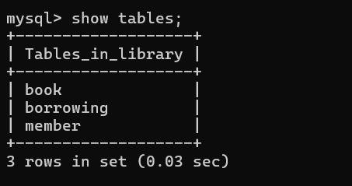

**question 6:**

